ASTA607_22424357
library(dplyr)

# Question 1
# a. Describe the dataset using the one in package MASS.
library(MASS)
# b. Load the dataset and display its structure
data("crabs")
# c. Produce the frequency table for species and sex
table(crabs$sp, crabs$sex)
# d. Construct an appropriate bar chart or mosaic plot summarising the group composition.
barplot(table(crabs$sp, crabs$sex),
beside = TRUE,
col = c("lightblue", "pink"),
legend = TRUE,
xlab = "Species",
ylab = "Frequency",
main = "Species and Sex Distribution")
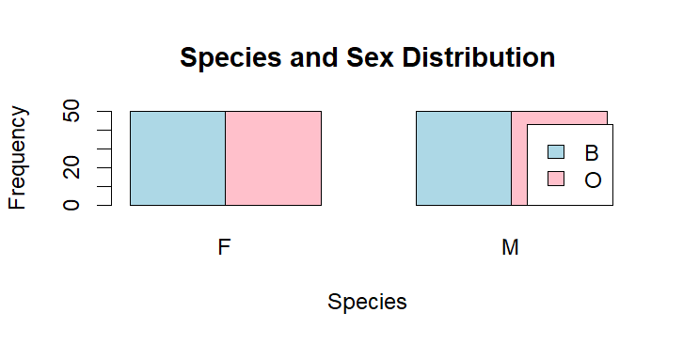

# e. Comment on whether the dataset is balanced across the four groups
# Yes — the dataset is perfectly balanced. 50 observations in each of the four groups
# Equal numbers across both species
# Equal numbers across both sexes

# Question 2 - Distribution of Body Depth
# a. Construct side-by-side boxplots of body depth (BD) for the four groups defined by species and sex
group <- interaction(crabs$sp, crabs$sex)

# side-by-side boxplots
boxplot(crabs$BD ~ group,
col = c("lightblue","lightpink","skyblue","salmon"),
xlab = "Species and Sex",
ylab = "Body Depth (BD)",
main = "Body Depth by Species and Sex")
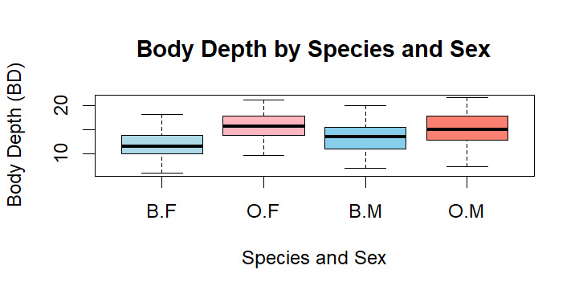

# b. Identify any outliers and compare the central tendency and variability between groups
by(crabs$BD, group, boxplot.stats) # there are no outliers

# Question 3 - Carapace Length Distribution by Species
# a. Produce hsitograms of carapace length (CL) for each species
# Set plotting area to 1 row, 2 columns
par(mfrow = c(1, 2))

# blue species
hist(crabs$CL[crabs$sp == "B"],
col = "lightblue",
main = "Carapace Length - Blue",
xlab = "Carapace Length (CL)",
breaks = 10)

# orange species
hist(crabs$CL[crabs$sp == "O"],
col = "salmon",
main = "Carapace Length - Orange",
xlab = "Carapace Length (CL)",
breaks = 10)

# resetting plotting layout
par(mfrow = c(1,1))
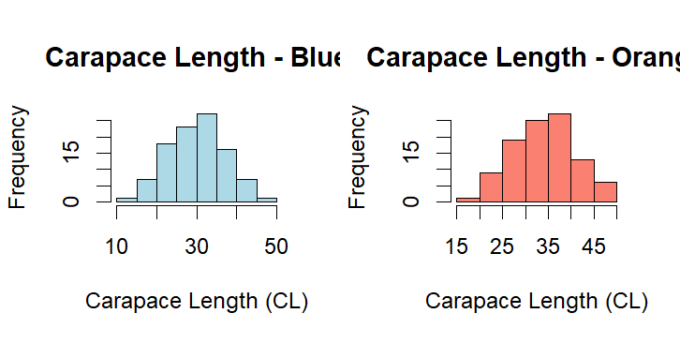

# b. Describe and compate the shapes of the distributions, commenting on skewness and modality
# - Shape and Modality
# Both species show approximately unimodal distributions.
# The histograms are fairly smooth without multiple distinct peaks.
# This suggests one main population per species
# - Skewness
#Both distributions are approximately symmetric.
#There may be slight right skew (a longer tail toward larger CL values), particularly among males.
# However, skewness is mild and not extreme.
# - Comparison Between Species
# The Orange (O) species tends to have slightly larger carapace lengths overall.
# The Orange distribution is shifted slightly to the right compared to Blue.
# The overall spread (range and variability) is quite similar between species.

# - Summary Interpretation
# Both species show roughly bell-shaped, unimodal distributions.
# There is no strong skewness or multimodality.
# The primary difference is a location shift, with Orange crabs generally larger than Blue crabs.
# Variability appears comparable across species.

# Question 4. - Comparison of Mean Measurements
# a. Compute the mean of each morphological measurements (FL, RW, CL, CW, BD) by species and sex
means <- aggregate(cbind(FL, RW, CL, CW, BD) ~ sp + sex,
data = crabs,
FUN = mean)

means

# b. Construct a grouped bar chart to display these means
# converting to matrix form (remove grouping columns)
mean_matrix <- as.matrix(means[, 3:7])

# setting row names
rownames(mean_matrix) <- paste(means$sp, means$sex, sep = ".")

# grouped bar chart
barplot(t(mean_matrix),
beside = TRUE,
col = c("lightblue","pink","lightgreen","orange"),
legend = rownames(mean_matrix),
xlab = "Morphological Measurement",
ylab = "Mean Value",
main = "Mean Morphological Measurements by Species and Sex")
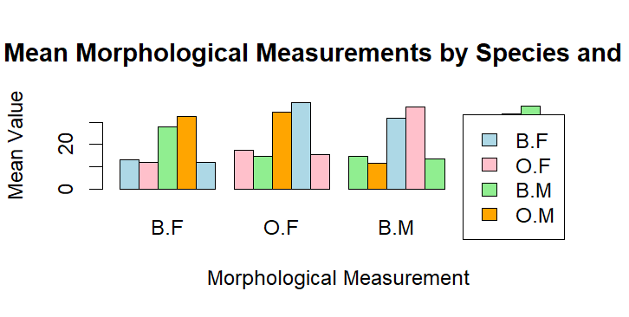

# c. Identify which measurement shows the greatest species difference and which shows the least sex variation.
# species means (averaged over sex)
species_means <- crabs %>%
group_by(sp) %>%
summarise(across(c(FL, RW, CL, CW, BD), mean))

species_diff <- abs(species_means[1,2:6] - species_means[2,2:6])
species_diff

# sex means (averaged over species)
sex_means <- crabs %>%
group_by(sex) %>%
summarise(across(c(FL, RW, CL, CW, BD), mean))

sex_diff <- abs(sex_means[1,2:6] - sex_means[2,2:6])
sex_diff

# Question 5
# a. Produce a scatterplot matrix (pair plot) of five measurements

pairs(crabs[, c("FL", "RW", "CL", "CW", "BD")],
main = "Scatterplot Matrix of Crab Measurements",
col = as.numeric(interaction(crabs$sp, crabs$sex)))
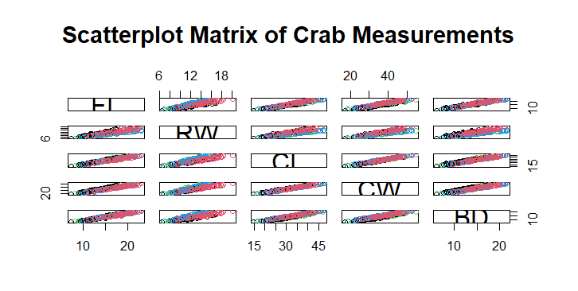

# b. Describe the strength and nature of the relationships among variables
# - Strength of Relationships
# All five measurements are strongly positively correlated.
# Larger crabs tend to be larger in all dimensions.
# This indicates strong overall body size dependence.

# - Nature of Relationships
# Relationships appear approximately linear.
# No obvious curvature or nonlinear patterns.
# No clear clustering beyond group differences.

# - Strongest Associations
# The strongest relationships are typically between:
# Carapace Length (CL) and Carapace Width (CW)
# Rear Width (RW) and Carapace Width (CW)
# These measure closely related aspects of overall shell size.

# The variables largely measure overall body size, so:
# They contain substantial redundant information.

# Question 6.
Statistical Report: Morphological Variation in Leptograpsus variegatus
1. Introduction and Data Description
The dataset contains morphological measurements for 200 crabs of the species Leptograpsus variegatus, structured by two categorical factors:
Species (sp): Blue (B) and Orange (O)
Sex: Male (M) and Female (F)
This creates four equally sized groups—Blue Female, Blue Male, Orange Female, and Orange Male—each with 50 observations, allowing clear comparisons across species and sex.

Five continuous morphological measurements were analyzed:
FL – Frontal lobe size
RW – Rear width
CL – Carapace length
CW – Carapace width
BD – Body depth

2. Group Composition
A frequency table and corresponding bar/mosaic plots confirm that the dataset is perfectly balanced, with 50 crabs in each species–sex combination. This ensures fair comparisons and simplifies interpretation of differences across groups.

3. Body Depth by Species and Sex
Side-by-side boxplots of body depth (BD) show clear patterns:
Sex effect: Males have larger median BD than females in both species.
Species effect: Orange crabs tend to have slightly higher medians than Blue crabs.
Variability is similar across groups, though male groups show slightly greater spread.

4. Carapace Length by Species
Histograms of carapace length (CL) indicate roughly symmetric, unimodal distributions for both species.
Orange crabs have slightly larger CL on average, but overall distribution shapes are similar.
Skewness is mild and positive, suggesting differences between species are mainly in overall size rather than distribution shape.

5. Mean Morphological Differences
Grouped means for all five measurements reveal consistent patterns:
Sex effect: Males have higher mean values across all measurements, highlighting sexual dimorphism.
Species effect: Orange crabs are generally larger than Blue crabs, though the effect is smaller than sex differences.
Notable observations:
Carapace Width (CW) shows the largest difference between species.
Frontal Lobe (FL) shows the smallest difference between sexes.
The measurements related to shell size (CL, CW) are most sensitive to species differences, while FL varies least by sex.

6. Relationships Among Morphological Measurements
A scatterplot matrix of FL, RW, CL, CW, and BD shows strong positive linear relationships:
All pairwise relationships are approximately linear, with correlations typically above 0.9.
No clear nonlinear patterns are observed.
Strongest associations: CL–CW and RW–CW.
This indicates substantial multicollinearity and that all measurements largely reflect a single underlying factor—overall body size. Differences between groups mainly reflect size rather than shape.

7. Overall Interpretation
The analysis highlights clear patterns of morphological variation in Leptograpsus variegatus:
The dataset is balanced across species and sex.
Orange crabs are generally larger than Blue crabs, with CW being the highest measurement.

